DAY 7 CLASS EXERCISE 727721EUIT033-DHIVYA DHARSHINI T

TASK 1:

**import** org.openqa.selenium.WebDriver;

**import** org.openqa.selenium.chrome.ChromeDriver;

**import** org.openqa.selenium.chrome.ChromeOptions;

**import** org.testng.annotations.Test;

**import** org.testng.Assert;

**import** io.github.bonigarcia.wdm.WebDriverManager;

**public** **class** NewTest {

@Test

**public** **void** f() {

WebDriverManager.*chromedriver*().setup();

WebDriver driver;

ChromeOptions co = **new** ChromeOptions();

co.addArguments("--remote-allow-origins=*");

driver=**new** ChromeDriver(co);

driver.get("https://demo.wpeverest.com/user-registration/guest-registration-form/");

String t="Guest Registration Form – User Registration";

String t1=driver.getTitle();

Assert.*assertEquals*(t, t1);

}

}

OUTPUT:

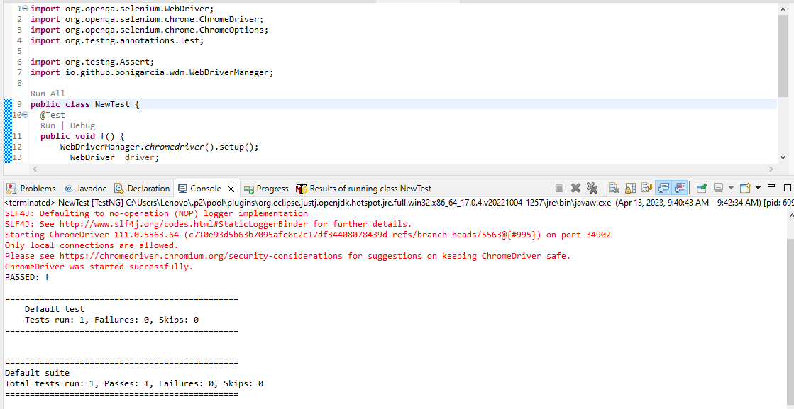

TASK 2

**import** org.testng.Assert;

**import** org.testng.annotations.Test;

**public** **class** NewTest4 {

**int** a=10,b=5,c;

@Test(priority=1)

**public** **void** add() {

c=a+b;

Assert.*assertEquals*(15, c);

}

@Test(priority=2)

**public** **void** sub() {

c=a-b;

Assert.*assertEquals*(5, c);

}

@Test(priority=3)

**public** **void** mul() {

c=a*b;

Assert.*assertEquals*(50, c);

}

@Test(priority=4)

**public** **void** div() {

c=a/b;

Assert.*assertEquals*(2, c);

}

}

OUTPUT:

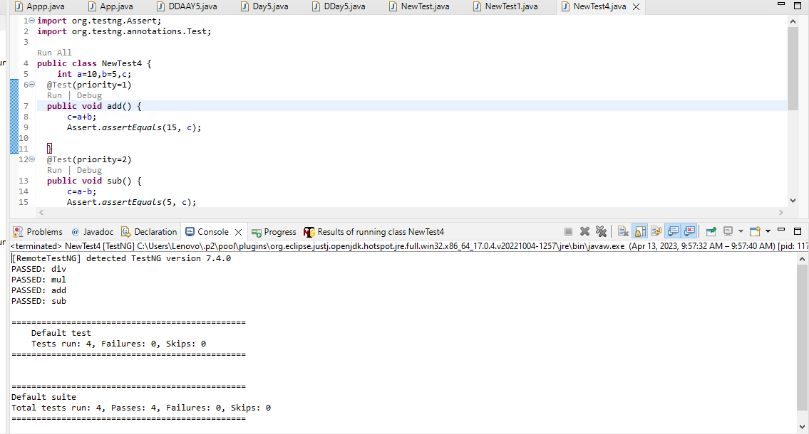

TASK 3:

package com.selenium.project1.selenium1;

import org.testng.annotations.Test;

import io.github.bonigarcia.wdm.WebDriverManager;

import org.testng.*;

import org.testng.annotations.BeforeMethod;

import org.openqa.selenium.By;

import org.openqa.selenium.WebDriver;

import org.openqa.selenium.WebElement;

import org.openqa.selenium.chrome.ChromeDriver;

import org.openqa.selenium.chrome.ChromeOptions;

import org.testng.annotations.AfterMethod;

public class NewTest2{

WebDriver driver;

@Test

public void f() throws InterruptedException{

Thread.sleep(3000);

WebElement uname=driver.findElement(By.name("username"));

WebElement pwd=driver.findElement(By.name("password"));

WebElement submit= driver.findElement(By.xpath("//*[@id=\"app\"]/div[1]/div/div[1]/div/div[2]/div[2]/form/div[3]/button"));

uname.sendKeys("Admin");

pwd.sendKeys("admin123");

submit.click();

String url1="https://opensource-demo.orangehrmlive.com/web/index.php/dashboard/index";

String ActualUrl=driver.getCurrentUrl();

Assert.assertEquals(url1,ActualUrl);

}

@BeforeMethod

public void beforeMethod() {

WebDriverManager.chromedriver().setup();

ChromeOptions co = new ChromeOptions();

co.addArguments("--remote-allow-origins=*");

driver=new ChromeDriver(co);

driver.manage().window().maximize();

String url="https://opensource-demo.orangehrmlive.com/web/index.php/auth/login";

driver.get(url);

}

@AfterMethod

public void afterMethod() {

driver.close();

}

}

OUTPUT:

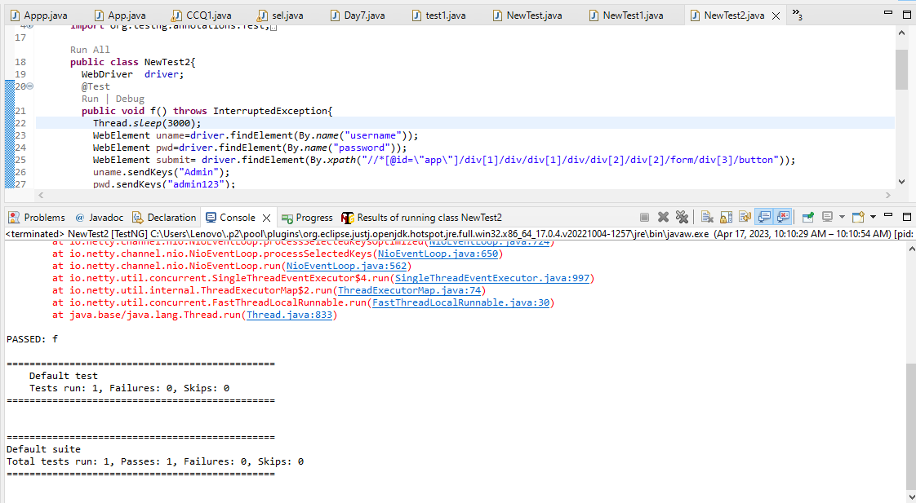

TASK 4:

package com.selenium.project1.selenium1;

import org.openqa.selenium.By;

import org.openqa.selenium.WebDriver;

import org.openqa.selenium.WebElement;

import org.openqa.selenium.chrome.ChromeDriver;

import org.openqa.selenium.chrome.ChromeOptions;

import org.testng.Assert;

import org.testng.annotations.BeforeSuite;

import org.testng.annotations.Test;

import io.github.bonigarcia.wdm.WebDriverManager;

public class test1 {

WebDriver driver;

@BeforeSuite

void init()

{

WebDriverManager.chromedriver().setup();

ChromeOptions co = new ChromeOptions();

co.addArguments("--remote-allow-origins=*");

driver=new ChromeDriver(co);

}

@Test

void Test1() throws InterruptedException

{ //open url and maximize

Assert.assertEquals(1, 1);

String url="https://opensource-demo.orangehrmlive.com/web/index.php/auth/login";

driver.get(url);

Thread.sleep(3000);

driver.manage().window().maximize();

//Entering uname, pwd and click login button

WebElement uname=driver.findElement(By.name("username"));

WebElement pwd=driver.findElement(By.name("password"));

WebElement submit=driver.findElement(By.xpath("//*[@class='oxd-button oxd-button--medium oxd-button--main orangehrm-login-button']"));

uname.sendKeys("Admin");

pwd.sendKeys("admin123");

submit.click();

}

@Test(dependsOnMethods = "Test1")

void Test2() throws Exception

{ //click profile option and click logout button

Thread.sleep(3000);

driver.findElement(By.xpath("//*[@id=\"app\"]/div[1]/div[1]/header/div[1]/div[2]/ul/li/span/p")).click();

Thread.sleep(3000);

driver.findElement(By.xpath("//*[@id=\"app\"]/div[1]/div[1]/header/div[1]/div[2]/ul/li/ul/li[4]/a")).click();

Thread.sleep(3000);

//verifying login page

String s1="OrangeHRM";

String s2=driver.getTitle();

Assert.assertEquals(s1, s2);

driver.close();

}

}

OUTPUT:

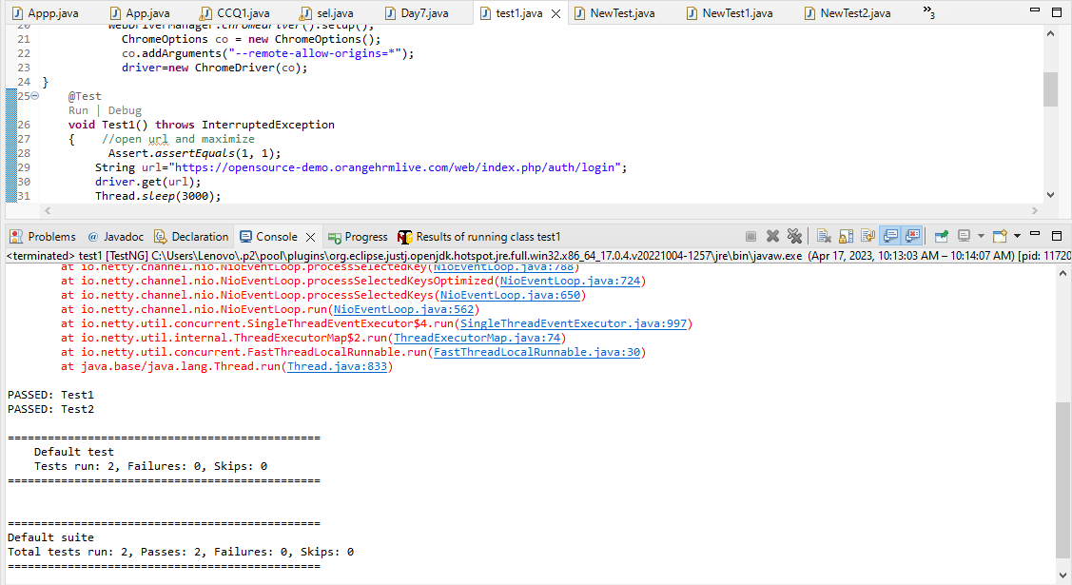

TASK 5

/* package com.selenium.project1.selenium1;

import org.testng.annotations.Test;

import io.github.bonigarcia.wdm.WebDriverManager;

import org.testng.*;

import org.testng.annotations.BeforeMethod;

import org.openqa.selenium.By;

import org.openqa.selenium.WebDriver;

import org.openqa.selenium.WebElement;

import org.openqa.selenium.chrome.ChromeDriver;

import org.openqa.selenium.chrome.ChromeOptions;

import org.testng.annotations.AfterMethod;

public class NewTest2{

WebDriver driver;

@Test

public void f() throws InterruptedException{

Thread.sleep(3000);

WebElement uname=driver.findElement(By.name("username"));

WebElement pwd=driver.findElement(By.name("password"));

WebElement submit= driver.findElement(By.xpath("//*[@id=\"app\"]/div[1]/div/div[1]/div/div[2]/div[2]/form/div[3]/button"));

uname.sendKeys("Admin");

pwd.sendKeys("admin123");

submit.click();

String url1="https://opensource-demo.orangehrmlive.com/web/index.php/dashboard/index";

String ActualUrl=driver.getCurrentUrl();

Assert.assertEquals(url1,ActualUrl);

}

@BeforeMethod

public void beforeMethod() {

WebDriverManager.chromedriver().setup();

ChromeOptions co = new ChromeOptions();

co.addArguments("--remote-allow-origins=*");

driver=new ChromeDriver(co);

driver.manage().window().maximize();

String url="https://opensource-demo.orangehrmlive.com/web/index.php/auth/login";

driver.get(url);

}

@AfterMethod

public void afterMethod() {

driver.close();

}

}

*/

**package** com.selenium.project1.selenium1;

**import** java.util.concurrent.TimeUnit;

**import** org.openqa.selenium.By;

**import** org.openqa.selenium.WebDriver;

**import** org.openqa.selenium.chrome.ChromeDriver;

**import** org.openqa.selenium.chrome.ChromeOptions;

**import** org.testng.Assert;

**import** org.testng.annotations.Test;

**import** io.github.bonigarcia.wdm.WebDriverManager;

**public** **class** NewTest2 {

@Test(groups= {"SmokeTest"})

**public** **void** f() {

WebDriverManager.*chromedriver*().setup();

WebDriver driver;

ChromeOptions co = **new** ChromeOptions();

co.addArguments("--remote-allow-origins=*");

driver=**new** ChromeDriver(co);

driver.get("https://www.godaddy.com/en-in");

driver.manage().window().maximize();

String actualTitle="Domain Names, Websites, Hosting & Online Marketing Tools - GoDaddy IN";

String extractedTitle=driver.getTitle();

Assert.*assertEquals*(actualTitle, extractedTitle);

String actualURL="https://www.godaddy.com/en-in";

String extractedURL=driver.getCurrentUrl();

Assert.*assertEquals*(actualURL, extractedURL);

System.***out***.println("Smoke test");

driver.quit();

//driver.manage().timeouts().implicitlyWait(10, TimeUnit.SECONDS);

}

@Test(groups= {"RegressionTest"})

**public** **void** f1() {

WebDriverManager.*chromedriver*().setup();

WebDriver driver;

ChromeOptions co = **new** ChromeOptions();

co.addArguments("--remote-allow-origins=*");

driver=**new** ChromeDriver(co);

driver.get("https://www.godaddy.com/en-in");

driver.manage().window().maximize();

//driver.manage().timeouts().implicitlyWait(5, TimeUnit.SECONDS);

driver.manage().timeouts().~~implicitlyWait~~(10,TimeUnit.***SECONDS***);

driver.findElement(By.*xpath*("//*[@id=\"id-631b049a-e9c0-4d24-8710-c504745206dd\"]/div[2]/div[1]/ul/li[1]/button")).click();

driver.findElement(By.*linkText*("Domain Name Search")).click();

System.***out***.println("Regressiontest");

//driver.quit();

}

}

OUTPUT:

